Worksheet 2
Сайт Московского зоопарка: https://www.moscowzoo.ru.
Виртуальный тур по Московскому зоопарку: https://www.moscowzoo.ru/vtour/.

- Complete the sentence. Every second letter in the clue will give you the missing word.
d | o | a | r | m | n | o | i | s | t | o | h | p | o | k | l | j | o | f | g | b | i | h | s | r | t

The person who studies birds is

- There are many groups (classes) of animals. All birds share some traits. What are they ?
Choose the right points:
- Care for their young
- Cold-blooded
- Have fur, or hair
- Have teeth
- Can fly
- Have feathers
- Have wings
- Lay eggs
- Warm-blooded
- Have beak or bill
- Give birth to live young
- Nurse their young with milk
- Have scales
What is a Bird? Give the definition.
____________________________________________________________________

- Match the words head, eye, beak/bill, wing, tail, claw, foot, breast, back, toe with the parts of the body.
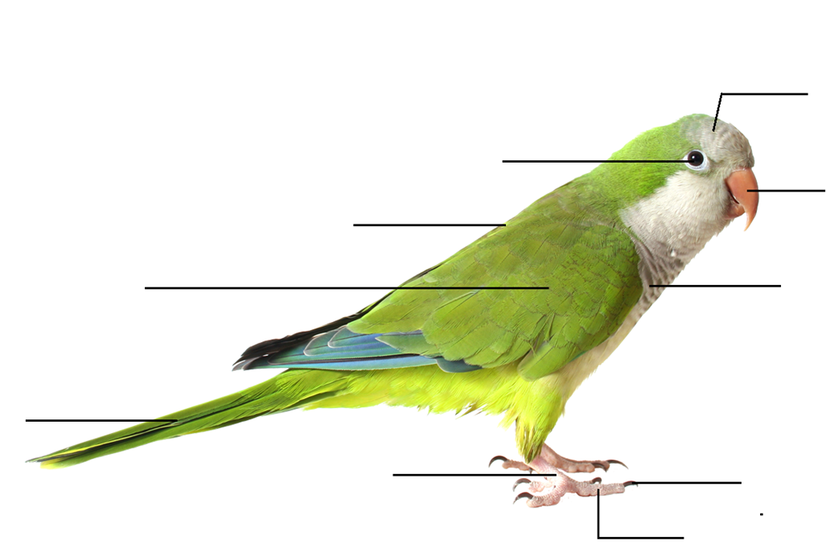

Feet аre adapted to help birds get their food and allow them to move around when they do not fly. Look at the pictures and find the birds in the pavilion. (Use
a virtual tour: https://www.moscowzoo.ru/vtour/ – main menu – Bird house).
(Use the museum website (section Birds): https://clck.ru/Sqn3k).
 | BIRD NAME  (Russian and English) | PHOTO
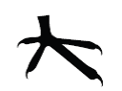
Scratching foot
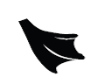
Swimming foot

How can bird’s feet tell about what the bird eats and where it lives?
____________________________________________________________________

- Compare two birds from the previous exercise.
SIMILARITIES

NAME_______________ NAME ___________________

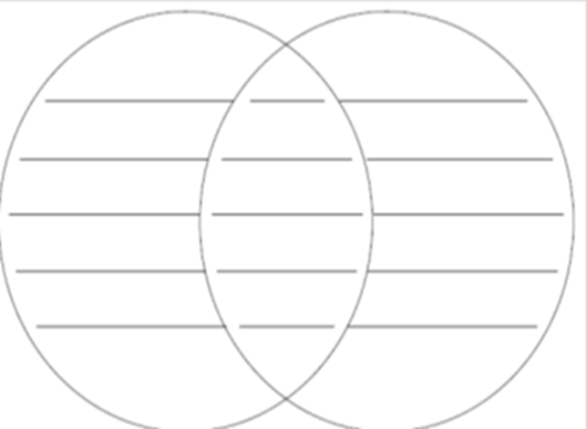

- Complete the chart by matching a colour to a bird that shares the same colour. Give the additional information about the birds.
COLOUR | RED | YELLOW | VIOLET | BLACK
BIRD NAME
(Russian and English)
SIZE

WEIGHT

NUMBER OF YOUNG

FOOD
Food/Eating Habits

HABITAT

DISTRIBUTION

Where do these birds live? On the map, color the geographic range of the birds.

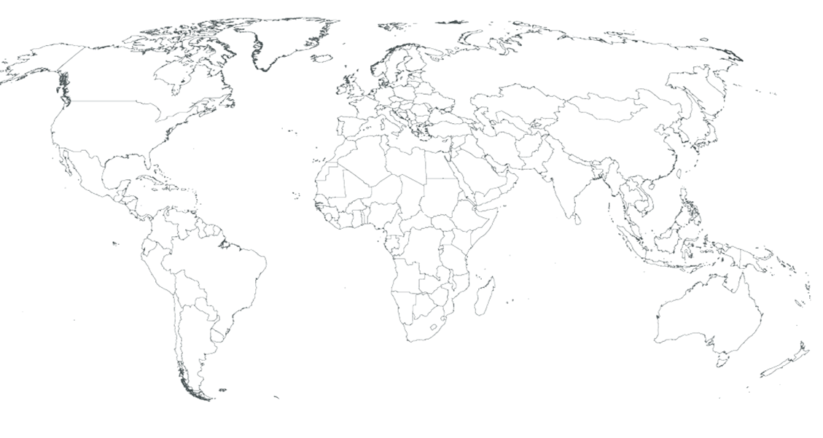

7. Team up with the student from the group 1 and create your own brochure devoted to the birds of Moscow Zoo using the information from the Tasks.

